Buccaneer Harvest Hunt
October 30, 2021
Sponsor Registration Form

___“Yes” – I would like to support the Xenia Community Schools Foundations Classroom Grants Program for Xenia Community Schools. (Pick sponsorship level below)
__ Hunt Supporter - $50.00 – Includes name on T-shirts and website.
__ Hunt Helper- $100.00 – Includes name on T-shirts, recognition on website and sponsor provided promotional items on display table.
__ Hunt Hero Sponsor - $250.00 – Includes name and one-color small logo on T-shirts, sponsor promotional materials on display table and recognition on XCSF website and on Facebook. Scavenger hunt stop adoption signage will be displayed at one stop.
__ Hunt Champion Sponsor - $500.00 – Includes name and one-color large logo on T-shirts, sponsor promotional materials on display table and recognition on XCSF website and on Facebook. Scavenger hunt stop adoption signage will be displayed at two stops.
Sponsorships are due by September 17, 2021
Name ______________________________________________
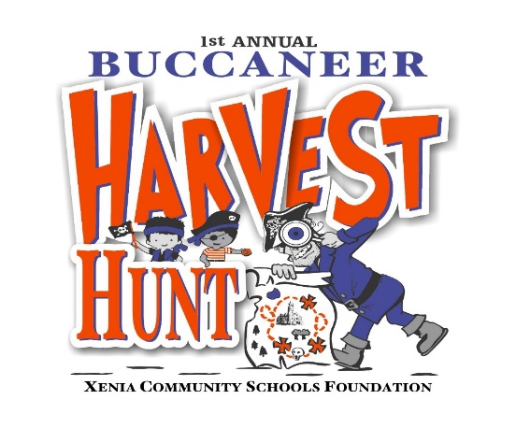
Company Name ______________________________________
Address_____________________________________________
___________________________________________________
Phone______________________________________________
Email_______________________________________________
Please return the form and check (payable to the Xenia Community Schools Foundation) to:
C/o The Xenia Area Chamber of Commerce
334 W. Market Street
Xenia, Ohio 45385

Questions? Call (937)-620-0790

